Data Definition Language (DDL) Exercise 1
Scenario: A university is developing a database system to manage students, courses, and enrollments. You are responsible for designing and implementing the database using SQL Data Definition Language (DDL).

Task 1: Data Definition Language
- What does DDL stand for?
Data Definition Language
- List two DDL commands:
- CREATE
- ALTER

Task 2: Creating a Table
Write SQL to create a Students table:
Fields:
- StudentID (INT)
- FirstName (VARCHAR(50))
- LastName (VARCHAR(50))
- Email (VARCHAR(100))
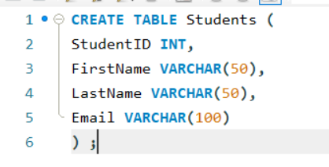
Task 3: Modifying a Table
Add a column DateOfBirth (DATE) to Students:
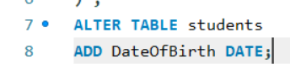
Task 4: Default Value
Set default value of EnrollmentStatus to 'Active'
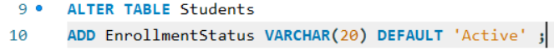
Task 5: Constraints
List three SQL constraints:
- Primary Key
- Not NULL
- Foreign Key

Task 6: Constraint Names
Why do we name constraints in SQL?
To avoid confusion and be able to reference and modify them by name.

Task 7: Auto Increment
What is AUTO_INCREMENT used for?
To generate an integer for each row.
Write SQL example:
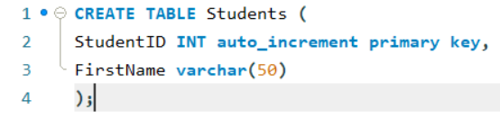

Task 8: On DELETE? ON UPDATE
Explain:
- ON DELETE CASCADE: When a parent is deleted, the rest of the children in the same row are deleted as well.
- ON UPDATE CASCADE: If a primary key in a parents row is updated the rest of the rows that have a foreign key update as well in order to match.

Task 9: UNIQUE Constraint
Write SQL to ensure Email is unique:
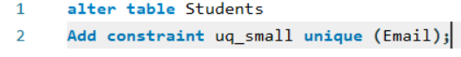
Task 10: CHECK Constraint
Ensure age is 18 or older:
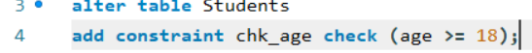
Task 11: CHECK Constraint
Give one example of a CHECK constraint:
Task 12: Dropping a Constraint
Write SQL to drop constraint chk_age:
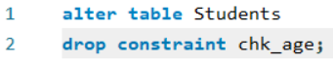
Task 13 Temporary Table
What is a temporary table used for?
Possibly for a transaction. When using it to create a table of someone purchasing something or for a session.
Write SQL:
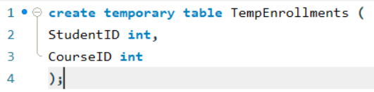
Task 14: Dropping a Table
Write SQL to delete Students table permanently:
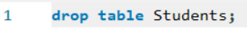
Final Challenge: Full DDL Design
Create a full database schema including:
- Students
- Courses
- Enrollments
Must include:
- Primary Keys
- Foreign Keys
- AUTO_INCREMENT
- DEFAULT values
- UNIQUE constraint
- CHECK constraint
- ON DELETE CASCADE
